**COMP3401/ Spring 20/ Project/Part1**

Q1] Select a real-life project from your own and get your project validated by the instructor. Then specify your project as follows

|  |  |  |
| --- | --- | --- |
| ***Students*** | ***ID*** | ***Name*** |
| 130786 | Mawada Khalfan Nasser Al Husaini |
| 128453 | Kalsoom Kanwal Shoukat Ali |
| 125854 | Manar Khalid Saif AL Aamri |
| ***Proposal (Title)*** | Delivery express Application | |
| ***Project Objective*** | It is an application for which you can assign yourself as a delivery worker or as a customer to request a delivery person to deliver your packages.  The objectives of the application:   * Provide jobs opportunity, either as a Part time or full-time job * Fast delivery services * The delivery service is available 24/7 * The customers consume less effort in finding a delivery person * It contains more credibility, sincerity and honesty | |
| ***Most important requirements in terms of Functions/ Services/Applications*** | The customer can:   * Choose the delivery time and day * Pay by credit or cash * Trace his delivery * Pick the delivery person among the workers who are available * Rate the delivery quality   The delivery person can:   * Find a job * Choose the working hours * Choose the areas where he can deliver * Either accept or reject the customer request depending on his capabilities | |

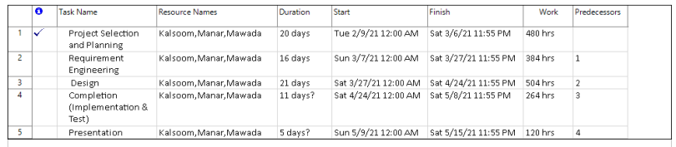Q2] Use any tool to schedule your project starting week 2 and ending week 14. We used Project Plan 365

Q3] Show the contribution of each team member

|  |  |
| --- | --- |
| **Team Member** | **Contribution** |
| Mawada | * Suggested some project’s ideas * Contacted with the instructor regarding to the project idea * Contributed in specifying part1 of the project * Filled Q1 of part1 * Contributed in Q2 of part1 |
| Kalsoom | * Suggested some project’s ideas * Suggested the Project’s name * Contributed in specifying part1 of the project * Filled Q3 of part1 * Contributed in Q2 of part1 |
| Manar | * Suggested some project’s ideas * Among all the project’s ideas, we finalized her idea. * Contributed in specifying part1 of the project * Filled Q4 of part1 * Contributed in Q2 of part1 |

Q4] Coordination: Show how did you coordinate your respective activities

The first step that was made on this project is selecting the group’s members. We started a group chat on WhatsApp for easier and faster communication, After that we started meeting online using google meet. Moreover, we used Gmail in order to share the project’s files.

|  |  |  |  |  |
| --- | --- | --- | --- | --- |
| **Number of meetings** | **Day /Date** | **Duration** | **Host of the meeting** | **Discussed subjects in the meeting** |
| 1 | Friday /  5-2-2021 | 1-2 Hours | Mawada | Gathering all the possible ideas for the project |
| 2 | Saturday /  6-2-2021 | 1-2 Hours | Mawada | We came up with the top ideas and selected the most suitable one |
| 3 | Tuesday /  3-2-2021 | 1 Hour | Mawada | We went over through part1 of the project and filled the first question |
| 4 | Wednesday /  3-3-2021 | Half Hour | Mawada | We filled the third question of part1 of the project |
| 5 | Thursday /  4-3-2021 | 1 Hour | Manar | We filled the fourth question of part1 of the project |
| 6 | Friday /  5-3-2021 | 1.5 Hours | Kalsoom | We filled the fourth question of part1 of the project. Furthermore, we went through part1 from the beginning to check all the answers |

**Grading**

|  |  |
| --- | --- |
| **Question** | **Weight** |
| Q1 | 20% |
| Q2 | 60% |
| Q3 | 10% |
| Q4 | 10% |